# USER GUIDE FOR YOUZU SINGAPORE

**Group members:**

Sim Sheng Xue

Justin Yip Jia En

Yu Ying Cheng

**USER GUIDE FOR YOUZU SINGAPORE** **1**

**User Guide for website** **2**

**1 Home** **2**

1.1 Uploading your own file 2

1.2 Processing provided file 3

1.3 Progress bar 3

1.4 Custom PDF page range 4

**2 Library** **4**

2.1 Library Overview 4

2.2 Library Actions 5

**3 Edit** **6**

IMPORTANT: The Edit page cannot be navigated to through the website. If the user refreshes the Edit page, all unsaved changes will be lost, and the user will be directed to the Homepage. 6

3.1 Overview 6

3.2 File Information 6

3.3 PDF preview 7

3.4 Editing of Individual Question 8

3.5 Buttons 9

**4 Database** **10**

**5 Changelog** **10**

**6 Settings** **11**

# User Guide for website

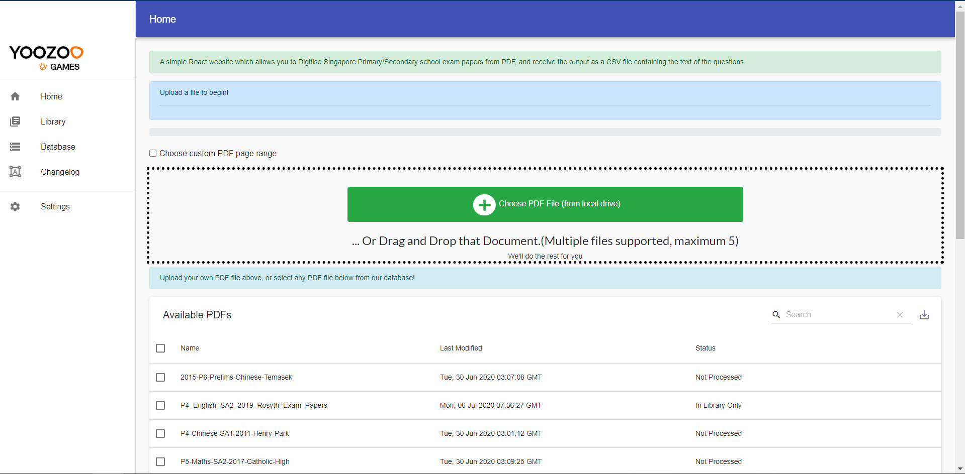

This user guide is for a simple React website which allows you to upload Singapore primary/secondary school exam papers in PDF, and receive the output of a CSV file containing the text of the questions.

# 1 Home

## 1.1 Uploading your own file



Click the green button to upload a file, which must in .pdf format, to the server. You can also drag and drop the files onto the dotted box. Multiple files can be selected or dropped at a time, but if you select more than 5 files, only the first 5 files will be processed.

## 1.2 Processing provided file

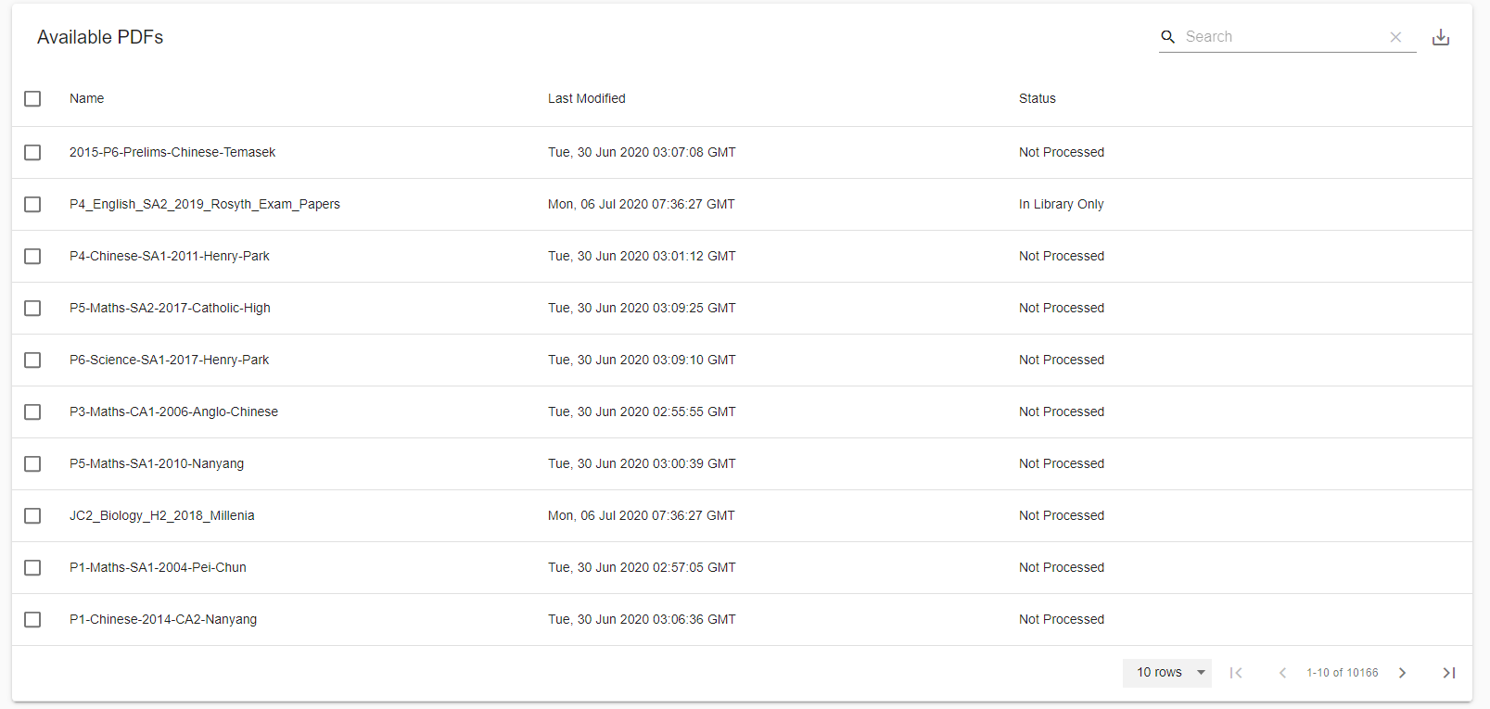

Up to 10,000 pdf files are provided on the website. These are listed in the form of a table. You can use the search bar to look for more specific files, such as English papers. The files can also be rearranged by clicking on the columns, such as name, last modified and status.

Select the files that you want to digitize, and click the Process PDF button on the top right. You may click the download button to download these files to your computer as well. For the Status explanation, please refer to section 2.1.

## 1.3 Progress bar



When you upload your own files or process provided files, the progress bar and a status will be displayed. If multiple files are selected, the corresponding tabs will open. There are three stages involved. The first two stages will be displayed in terms of the number of pages, while the third stage will be displayed in terms of the number of questions detected. When the file is processed, the page will automatically be navigated to the Edit tab.This happens automatically for the other tabs opened too.

## 

## 1.4 Custom PDF page range



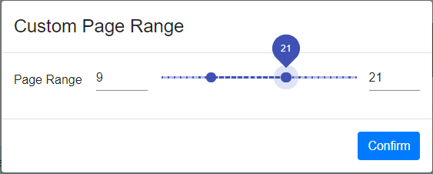

Check the box “Choose custom PDF page range” before uploading or processing files. IF it is selected, a pop up will appear prompting the user to select the page range. The pdf file will automatically be truncated. Please note that if not all of the pages of a pdf file is processed, the Status in the table will still remain as “Not Processed”. Instead, a unique reference to the truncated pdf file will be created in the workspace.

# 2 Library

## 2.1 Library Overview



The library stores the saved workspaces of the user. When a user processes a pdf file, the user can choose to save the resulting workspace in a library. Each workspace has a Name, Last Modified, and Status.

Status can be three types: Not Processed, In Library Only, and In Library and Database. The pdf file is considered in the Library if the “Save Workspace” button is clicked in the edit tab, and is considered in Database if “Upload all Questions to Database” or “Upload Selected Questions to Database” is clicked. Currently the status of 'In library' will only be updated if the entire exam pdf is processed (processed files with custom page range will indicate 'not processed').

## 2.2 Library Actions



For each workspace in the library, the following actions can be executed:

Open workspace:  Opens the workspace in a new tab

Edit: Modify the name of the workspace.

Delete: Delete the workspace(Cannot be undone)



For the library, the following actions can be executed:

Search:  Enter your search, and it will automatically update

Download as CSV: Download entire table if no search result is entered, else download search results only

Reload Data: Reloads the table from server

Clicking on ‘Last Modified’ will list the files according to their last modified date, in descending order.



Clicking on the ‘Export’ icon as shown above will enable the user to download the information of processed workspaces into a csv file.

# 3 Edit

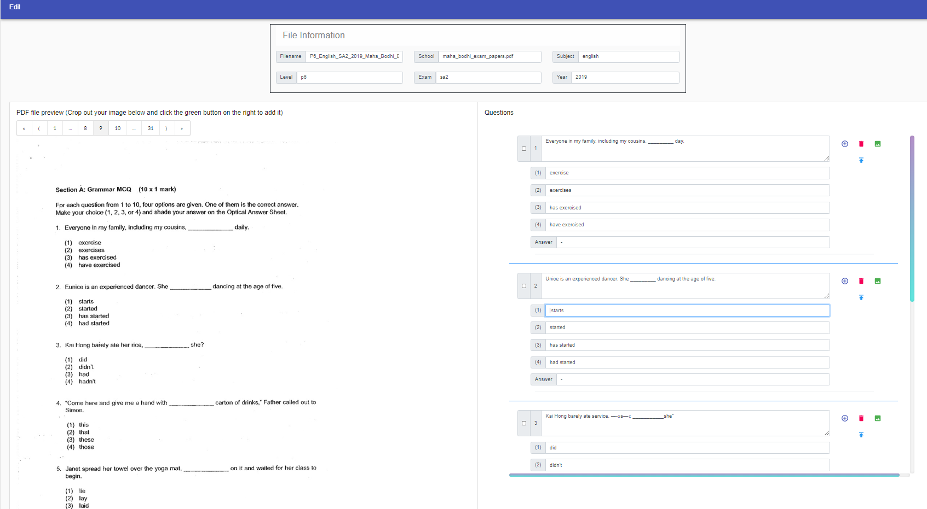

## **IMPORTANT: The Edit page cannot be navigated to through the website. If the user refreshes the Edit page, all unsaved changes will be lost, and the user will be directed to the Homepage.**

## 3.1 Overview

The above figure is an example of a typical edit page for an english paper with MCQ question type. On the left, a preview of the selected page of the question paper can be viewed by the user, while the right side is the interface to edit and inspect the question content.

## 3.2 File Information

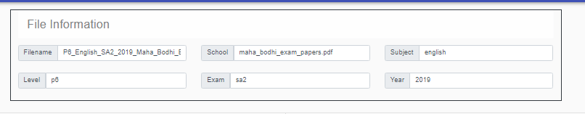

This section enables the user to edit the relevant information of the selected paper. The changes will be reflected in the downloaded csv and database after being saved and uploaded. As a form of standard procedure, we advise users to leave the filename intact and as default as much as possible.

## 3.3 PDF preview

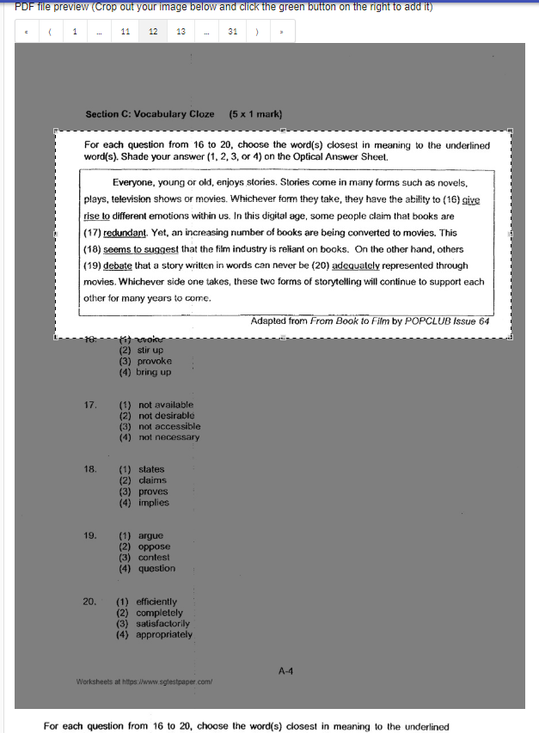 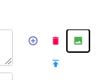

A preview of the processed pdf file is shown. If a custom page range is chosen, the truncated pdf file will be shown. Furthermore, the user can left click on the preview to “crop” the current page. The “cropped” section preview will be shown right below the pdf file. After selecting the “cropped” section, the user can click on the green button “Add cropped image” to add this image to the corresponding question.

To add cropped images across pages, the user can first click on the grey area on the pdf preview after cropping out the selected region and ensure that the preview at the bottom is correct. Next, navigate to the relevant page and click on the green button next to the appropriate questions. The cropped image will then be appended to the selected questions.

## 3.4 Editing of Individual Question

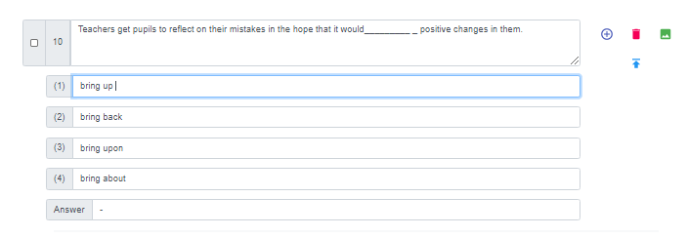

The questions are organized into pages. Each question consists of the question number, question title, four answer choices, the correct answer, as well as the images. For ease of editing, the user can use the ‘tab’ key to navigate to the next row.

Question number: This number is automatically provided, and it follows the current number of questions in the workspace.

Question title and Answer choices: Currently, we provide the answer choices which are meant to support MCQ questions only. Future implementations will remove the answer choices for structured questions. The default content for the ‘Answer’ row is a ‘-’ and the user is required to fill in the correct content. (Note:Questions with default ‘-’ as answer will not be uploaded to database when the buttons are clicked)

Images: Multiple images can be tagged onto a single question. This will be shown in terms of the Base64 format in the downloaded csv file. The user can click on the image to expand it.

In addition, there are four buttons that are shown beside each question. They are the “Add a new question below”, “Delete the question”, “Add cropped area on preview to this question”, and “Upload your own diagram”.

Add a new question below: Creates a blank question right below the current question, on the same page. Note that all the question numbers in allpages will automatically be updated, which will also be reflected in the csv file. The contents of the new question will all be “-” dashes.

Delete the question: Delete this *single* question only. Question numbers will also be automatically updated.

Add cropped area on preview to this question:As explained in section 3.3, select the cropped image through the pdf preview on the left and click this button to tag the image to this question. The added image will be shown below the question. The image can be deleted by clicking the corresponding cross button.

Upload your own diagram: As with adding a cropped image, you can click this button to upload your own diagram instead, which will be tagged to this question.

## 3.5 Buttons

## 

Save Workspace:Clicking on this button will enable the user to save their edits as a copy under the library tab. A prompt will appear after saving the file, serving as confirmation that the action is successful and recorded. Users can access this copy again by selecting from the Library tab.

# 

Download as .csv: A copy of the paper with edited questions in its current state will be downloaded in the form of the csv.

Revert to original: All changes made to the workspace will be undone, this includes adding or deleting questions, editing of the question contents etc. Please note that it only reverts to the time when you opened the workspace. If you saved and closed the workspace, this will be the last checkpoint when the workspace is opened again.

Upload all Questions to Database: 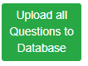All edited questions which do not have the default ‘-’ as an answer will be uploaded to the ‘qbank’ table in the database. Questions with its contents will be uploaded individually and every question will appear as a row entry. If no questions from the selected paper is present in the database, the questions will be immediately added and a prompt will indicate a successful upload. However, in the event that the database already contains questions from the same paper, a prompt like the one shown on the bottom right will appear to notify the user. Upload will proceed upon clicking on ‘OK’, and the previous entries for the same paper will be overwritten. Otherwise, the user can cancel the action and retain the previous record in the database by clicking on ‘Cancel’.

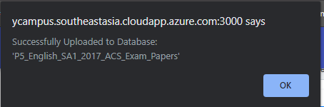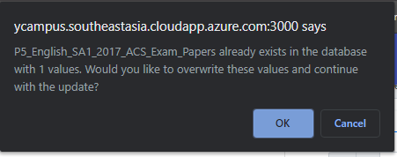

Upload selected Questions to Database: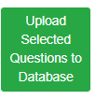This is the same as the above ‘upload all questions to database’ button, but with the additional criteria that only the questions with the checked checkbox will be considered.

Delete Selected Questions: 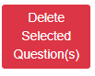All questions with the checked checkbox will be deleted.

# 4 Database

The questions which the user upload is stored in a Database. Each question contains the following components:

question: The question title

1: Answer choice 1

2: Answer choice 2

3: Answer choice 3

4: Answer choice 4

answer: The correct answer choice

Page: The page the question appeared in

number: The question number

question_type: Either MCQ or structured question

level: School level, such as P1-P6

subject: Subject of the question, such as English or Mats

year:-

school: -

# 5 Changelog

The updates for each of the versions is shown here.

# 6 Settings

To be implemented in the future.